**StressOmeter Application Documentation**

**1. Introduction**

**Project Name:** StressOmeter  
**Objective:**  
The **StressOmeter** app is designed to help users track and manage their stress levels. It allows users to log their mood, track stress trends over time, and receive personalized activity suggestions to help reduce stress. By logging daily stress levels and reflecting on their emotional well-being, users can take steps toward managing stress effectively.

The app provides features such as:

* **Mood Logging:** Users can log their stress level on a scale (e.g., low, medium, high) each day.
* **Activity Suggestions:** Based on the logged stress levels, the app suggests relaxing activities to help users de-stress.
* **Stress Trend Graph:** A visual representation of stress levels over time, showing patterns and changes.
* **Journaling:** A space for users to reflect on their stressors and share their feelings through writing.

**2. Features**

1. **Mood Logging:**
   * Users can select their stress level on a scale of low, medium, or high.
   * The app allows users to log their daily mood.
2. **Activity Suggestions:**
   * Based on the selected stress level, the app suggests specific activities such as light exercise, meditation, or relaxation practices.
3. **Stress Trend Graph:**
   * A graph or chart shows stress trends over time to visualize progress and help users identify triggers or patterns.
4. **Journaling:**
   * Users can write their thoughts, feelings, and experiences, helping them reflect and process stress in a healthy way.

**3. Architecture**

The architecture of the StressOmeter app is designed to be simple yet effective, with a focus on tracking data and suggesting meaningful actions to users. Below is a high-level overview of the architecture:

* **Frontend (Flutter):**
  + The user interface is built using Flutter, providing cross-platform support for both iOS and Android devices.
  + Core components include the home screen, mood log page, trend graph page, activity suggestion page, and journaling page.
* **Backend (Firebase):**
  + Firebase is used to store user data, including mood logs, journal entries, and activity suggestions.
  + Firebase Firestore database is used to store and retrieve data related to user profiles, stress logs, and notifications.

**4. Flowchart**

1. **Home Screen:** The user is greeted with the home screen, which contains the "How Stressed Are We Today?" button.
2. **Mood Logging:** The user selects their current stress level (low, medium, high).
3. **Activity Suggestions:** Depending on the selected stress level, the app suggests a specific activity.
4. **View Stress Trend:** Users can access a graph to see their stress levels over time.
5. **Journaling:** Users can reflect and write about their stress.

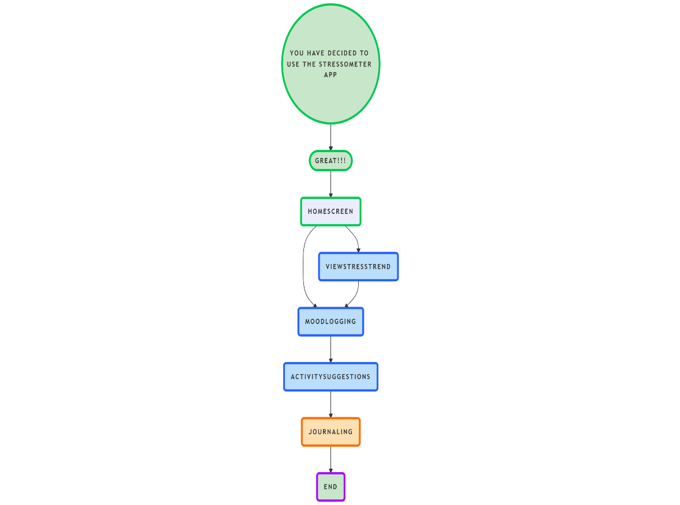

**5. Technical Stack**

1. **Flutter:**
   * Used for developing the frontend of the app. Flutter provides a smooth user interface for cross-platform applications.
2. **Firebase:**
   * Firebase Firestore is used as a real-time database to store and retrieve mood logs, stress data, and activity suggestions.
3. **State Management:**
   * **Provider** or **Riverpod** can be used for state management to manage the data flow across the app.
4. **Charts:**
   * **flutter_charts** or **fl_chart** can be used to display the stress trend graph.

**6. UI Components**

* **Home Screen:**
  + Contains a button to start the mood logging process.
  + Displays the current stress level and possible activities.
* **Mood Log Page:**
  + Allows the user to log their stress level for the day.
  + Provides a simple interface with options to select low, medium, or high stress.
* **Stress Trend Graph Page:**
  + Displays a graph showing the user's stress levels over time.
  + Helps users visualize their stress patterns and track progress.
* **Activity Suggestion Page:**
  + Shows personalized suggestions for activities based on the user's current mood (e.g., light exercise, meditation, etc.).
* **Journaling Page:**
  + Users can enter their thoughts and feelings in a text box to help process their emotions.

**7. Conclusion**

The **StressOmeter** app is designed to empower users to take control of their emotional well-being. By providing tools to log their moods, track stress trends, receive personalized activity suggestions, and reflect on their feelings through journaling, StressOmeter helps users manage stress effectively. The app's user-friendly interface ensures a smooth experience, and the backend system, powered by Firebase, keeps user data secure and readily available.

The ultimate goal of the **StressOmeter** app is to support individuals in their journey to manage and reduce stress, ultimately leading to better mental health and overall well-being.